**Super Servoli Systems**

**Business/User Requirements Document**

**First draft**

Project: Super Servoli Systems

Author: Hao Dong

**Table of Contents**

Project Overview 3

1.1 Audience 3

1.2 Glossary of Terms 3

Document Information 3

Business Opportunity 4

4.1 Project Overview and Background 4

4.2 Current State Analysis 4

4.3 Future State Objectives 5

4.4 Stakeholders 5

Business Requirements 6

Business Scope 6

Detailed Business Requirements 7

External Data Feeds 7

Business Risks 8

# **Project Overview**

This document describes requirements for Super Servoli Systems that will be used as the basis for the following activities:

* The system helps to expedite ordering and service
* Allow different types of restaurants like fast-food restaurants, take-out restaurants, pop-up restaurants, bars, concessions, and fast-casual restaurants to customize and adapt the system based on their own requirements
* The system is used by allowing customers to order food, and select the location where they wish to sit throughout the restaurant.
* Deliver web and mobile applications with the paypal payment API. The system has the option of accepting credit cards, debit cards, and cash.

# **Document Information**

**1.1 Audience**

|  |  |  |
| --- | --- | --- |
| **Business Group** | **User Roles** | **Team Member Name** |
| **Restaurants Stores Management** | **Partner Relationship Manager(responsible for local restaurant partners)** | **Poovadol** |
| **Advertisement Sales Management** | **Advertisement Sales Representative**  **Food popularity trend Analyst**  **Recipe Specialist** | **Jaepil** |
| **Subscription/ Account Management** | **Account Manager** | **Hao** |
| **Finance Management** | **Accountant** | **Ryan** |
| **Daily Need Management** | **Daily Need Manager**  **Recipe Specialist** | **Andy P** |

**1.2 Glossary of Term**

|  |  |
| --- | --- |
| **Term/Acronym** | **Definition** |
|  |  |
|  |  |

# **Business Opportunity**

4.1 Project Overview and Background

We aim at providing an app that can be personal customized by the client such as different types of restaurants. The app will help the customers in the restaurant easier to order food, book tables and set-up reservations themselves. And for the restaurants, labor is a huge part of cost. The service would reduce this cost too. Thus, the app is very useful to both restaurant side and customers in the restaurant side. For the payment, the app will be inserted a paypal API for the secure of the transaction. The whole system has the option of accepting credit cards, debit cards, and cash.

4.2 Current State Analysis

Nowadays, the technology of the mobile devices and the internet have been getting really mature. Everybody has a smart phone with a lot of apps installed on the devices. Since the pace of the life in 21 century is getting really fast, people have to spend more time on the work and less time getting and eating food, we created this Super Servoli Systems to help both restaurants and customers in the restaurants to have faster and supreme services. The idea of the app was taken from Evoke (McDonald’s), ConnectSmart Hostess (Red Lobster, Olive Garden), Ribot (KFC), Opentable(Restaurant booking service). The project will be written in JavaScript. The DB will be Google firebase.

4.3 Future State Objectives

The time between a customer placing an order and receiving their food would be shortened significantly along with an easy to use interface to make selections simple. The software simply removes the need to have people tracking orders and instead track it on software. This would greatly reduce errors made in taking someone’s order. Eliminate the need for customers to rely on calling a restaurant to book a reservation.

4.4 Stakeholders

The following table shows stakeholders of Super Servoli Systems.

|  |
| --- |
| Project Team |
| Project Manager |
| Partner Relationship Manager(responsible for local restaurant partners) |
| Advertisement Sales Representative |
| Food popularity trend Analyst |
| Recipe Specialist |
| Account Manager |
| Accountant  Daily Need Manager |

# **Business Requirements**

**Business Scope**

The users of the app will be able to allowing customers to order food, and select the location where they wish to sit throughout the restaurant. The system helps to expedite ordering and service. The system has the option of accepting credit cards, debit cards, and cash.The idea of the app was taken from other food ordering apps.

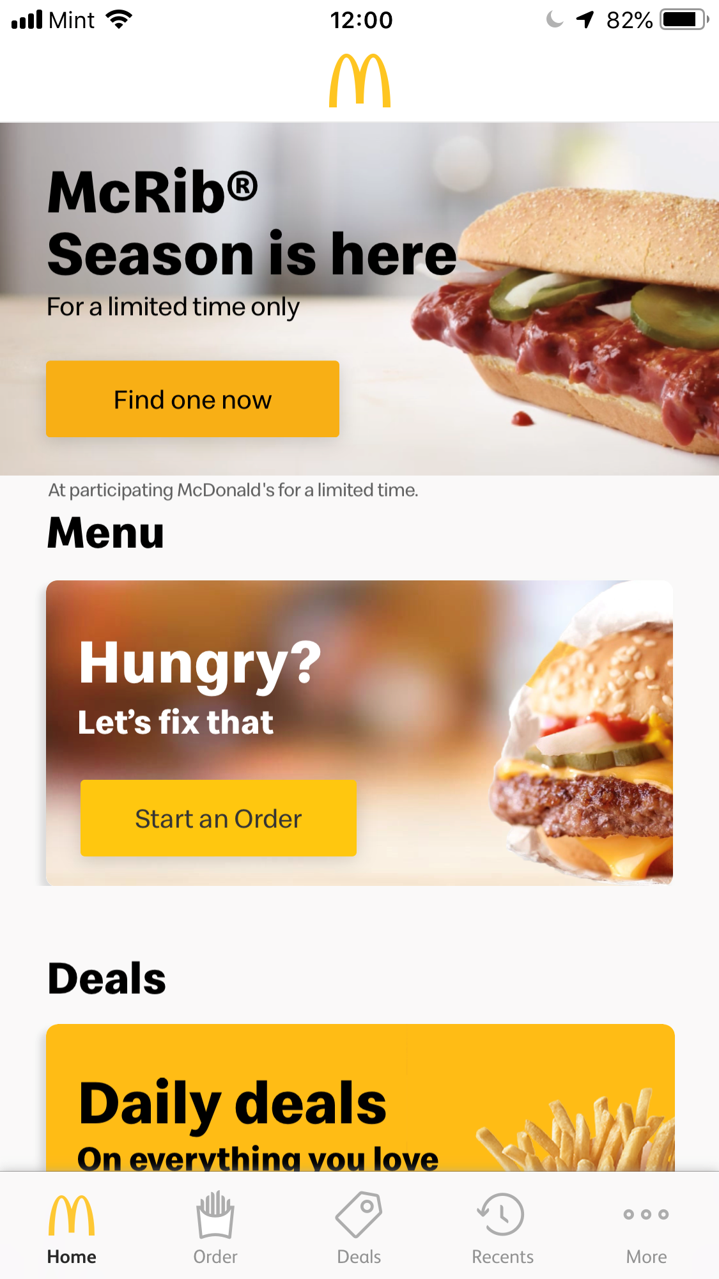

**Details of business requirements**

5.1 Restaurant store management

5.1.1 ability to supply help to any local restaurant which got registered in our system

5.1.2 ability to inform all the emergency information to any local restaurant which got registered in our system in time

5.2 Subscription/Account management

5.2.1 secured database

5.2.2 user-friendly interface

5.2.3 ability to show existing

5.2.4 consistency with existing system

5.3 Finance management

5.3.1 Validate card details.

5.3.2 ability to manage all the transactions

5.3.3 ability to accept bill payment from user

5.3.4 ability to display payment status

5.4 Advertisement Sales Management

5.4.1 user-friendly interface

5.4.2 ability to make attractive advertisement

5.5 Daily need management

5.5.1 ability to know what food customers mostly need

5.5.2 ability to know what stuff restaurants mostly need

# **External Data Feeds**

**Email/SMS notification interface:** It is a part of our communication system module. Will be used for users to send emails or messages directly to the admin.

**Google/ Facebook login interface:** If the user wants to login through Google or Facebook instead of logging in by registering to our system they can use this functionality.

**Credit card payment interface:** This interface will be used to enable payment functionality for the users to add payment method and make a payment such as Paypal, Apple pay cash, Venmo, Zelle, etc.

# **Business Risks**

If the service of the system got hacked, web crashes occur, the application might not work as expected, this will be the biggest business risk, because it will make the customers of the restaurants stop using their app and instead customers might choose other restaurants which has stable quality service. That means restaurants will lose a lot of customer source and money. It will also makes restaurants decide to choose other stable system to stop the loss in time.